**Subset sum problem using genetic algorithm**

Problem: we have set consist of negative and positive integers and we are going to find subset that the sum of its integers is 0 or nearest to 0

Type of encoding: Permutation Coding

We use (gen_population) function: to generate initial population

Number of chromosome up to user

Number of genes in each chromosome is randomly

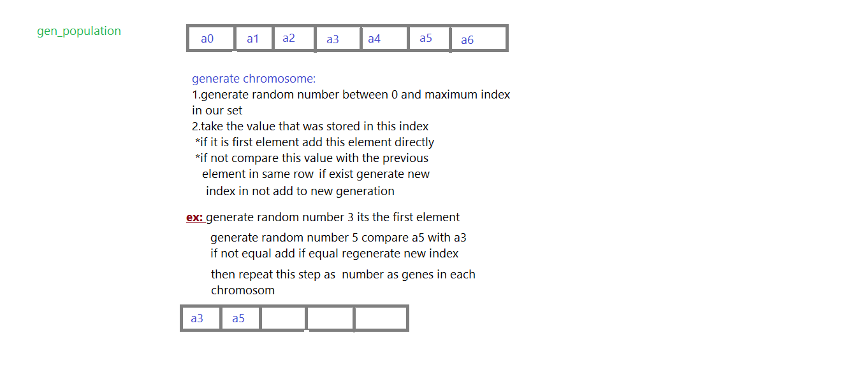

Fitness function: sum of genes in each chromosome

Types of selection: was used three type of selection in two methods (Roulette, Tournament selection, elitist selection)

Which method will be used up to user but we advise use second method

1. elitist with Roulette

2. elitist with tournament{ number of T elements up to user}

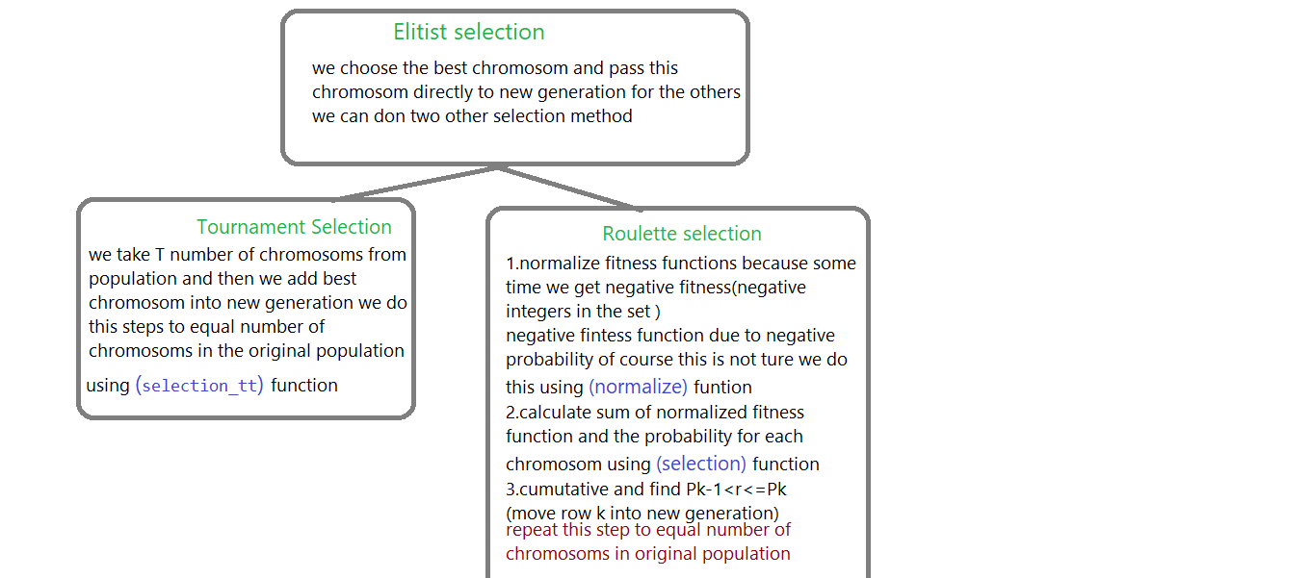

Choose the best chromosome will be like this:

